**Assignment 8 – April 17**

**OUTPUT**

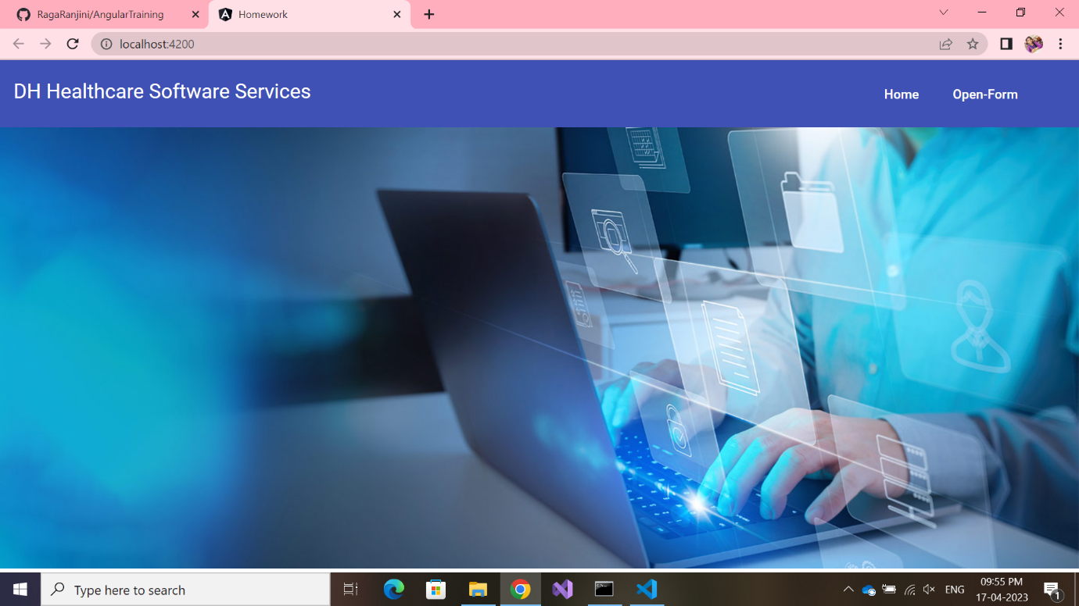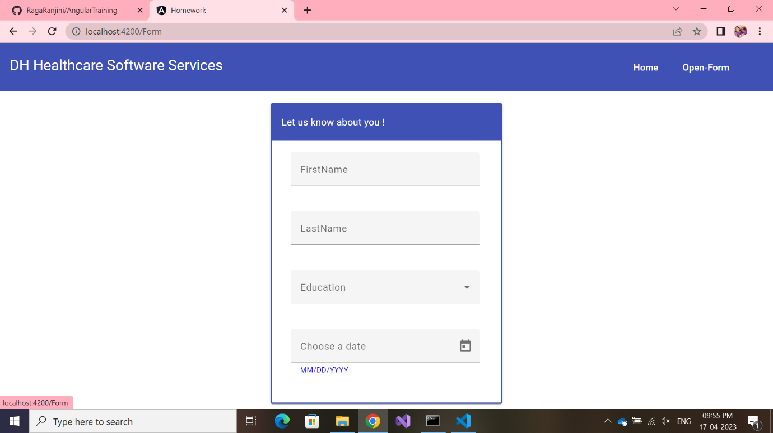

Commands “ng g m material” is used to create “material.module.ts” file, then configure it lie this to import all required modules.

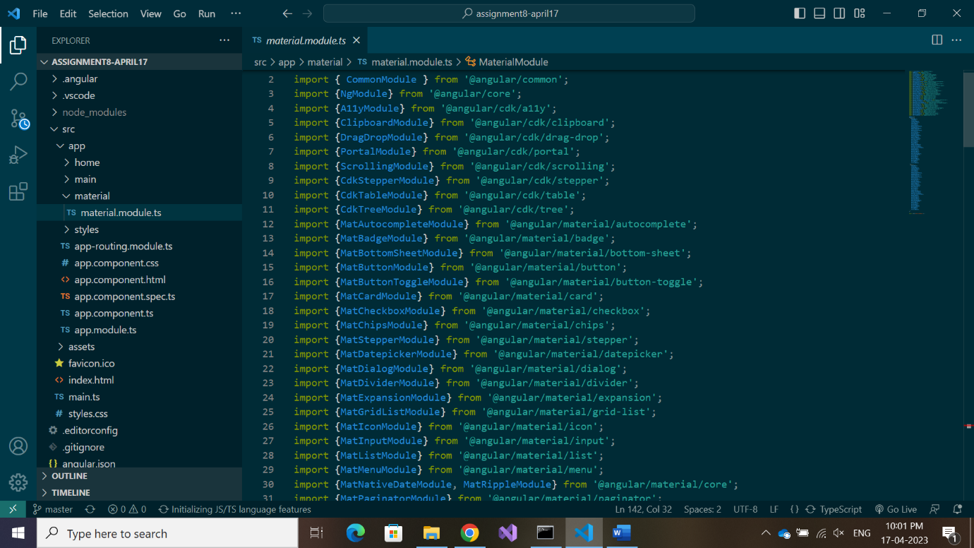

We import material module to our project in app.module.ts

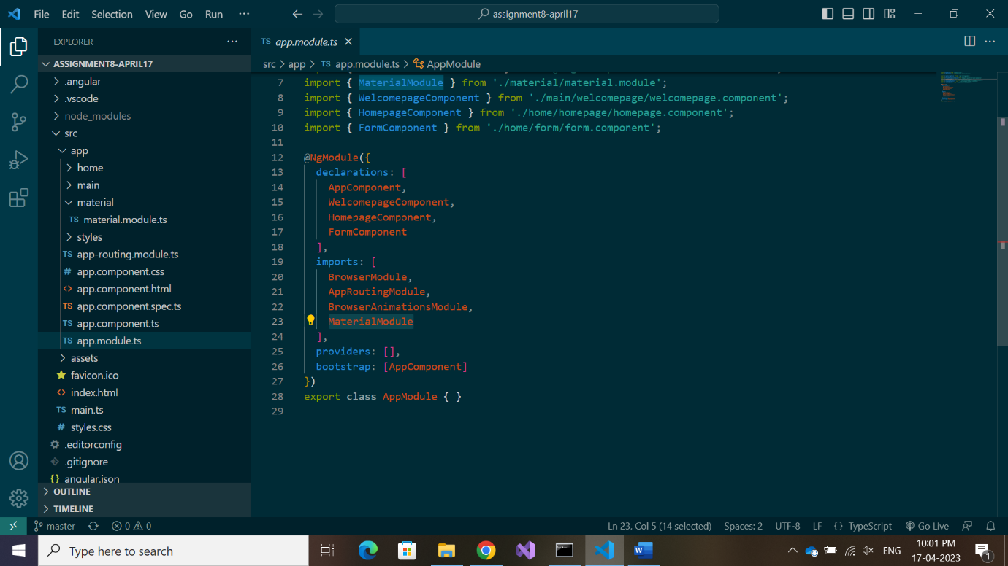

app.component.html:

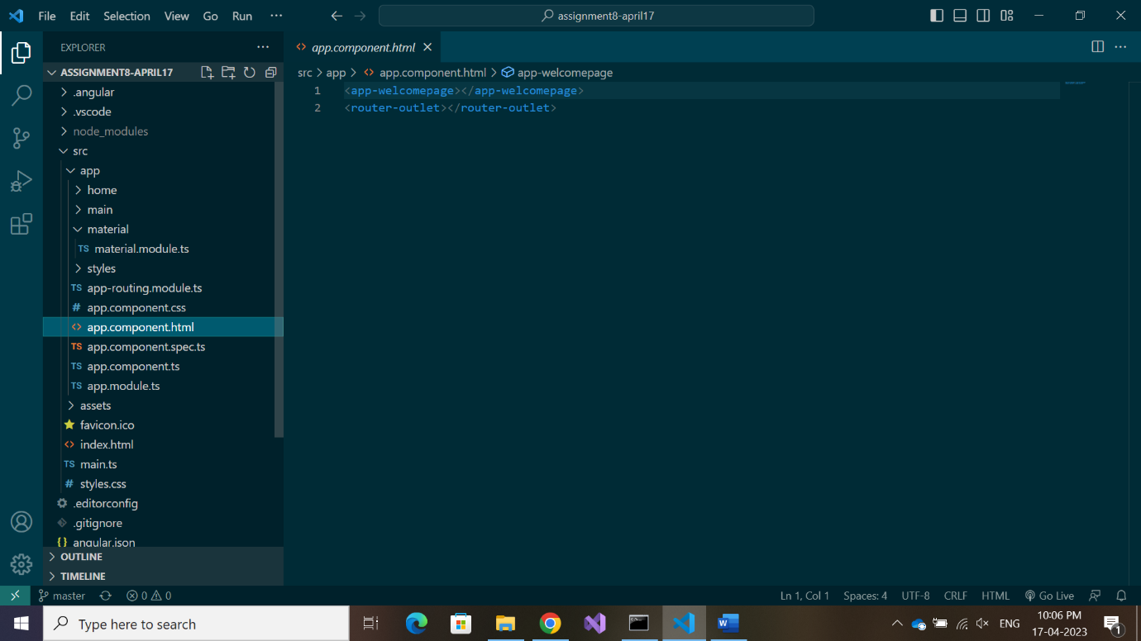

Welcomepage component is called, which contains the menu bar using toolbar of material module.

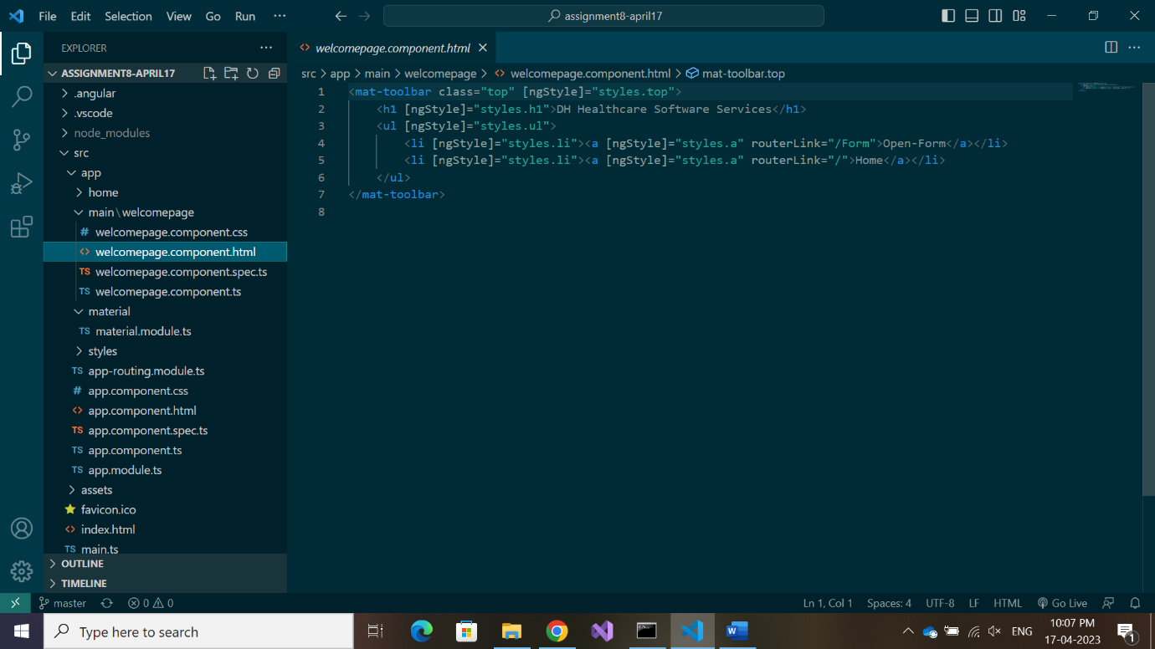

Each anchor tag is linked with a routerLink. The component to which this routerLink takes to

is defined in app-routing.module.ts and that component content occupies the <router-outlet> part , hence the toolbar in welcomepage stays constant.

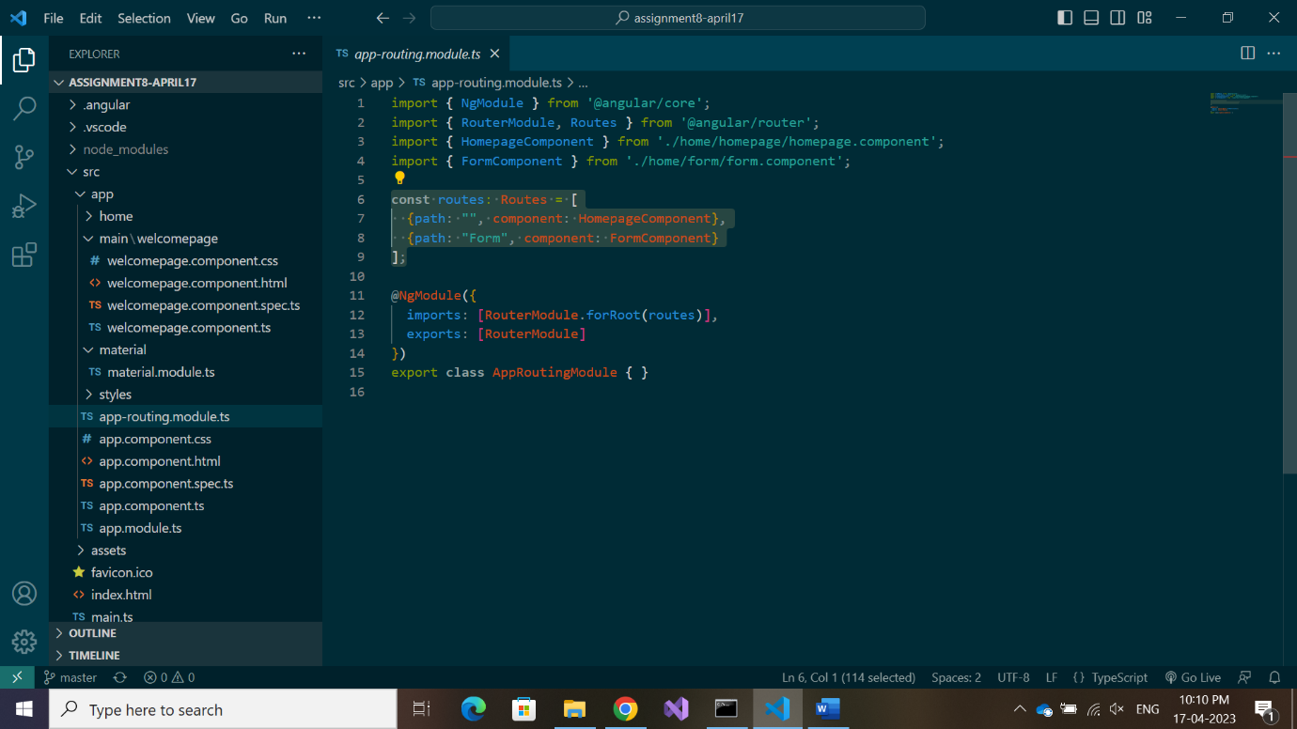

Hence, ‘home’ link takes to homepagecomponent while ‘open-form’ link heads to formcomponent.

Homepage component displays a background image, which initially be present everytime the screen is loaded.

Form component displays a window box with fields .